Họ và tên: Lê Bá Khánh Trình

MSSV: 6151071108

Lớp: CNTT K61

**(2) Oracle Operator**

1. Write a query to list the name of all the employees who are working in department number 20. 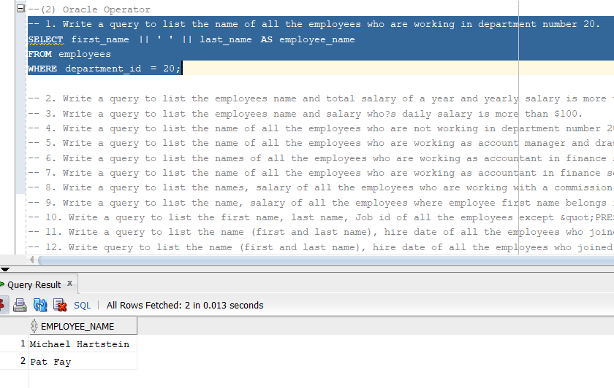

2. Write a query to list the employees name and total salary of a year and yearly salary is more than $10000. 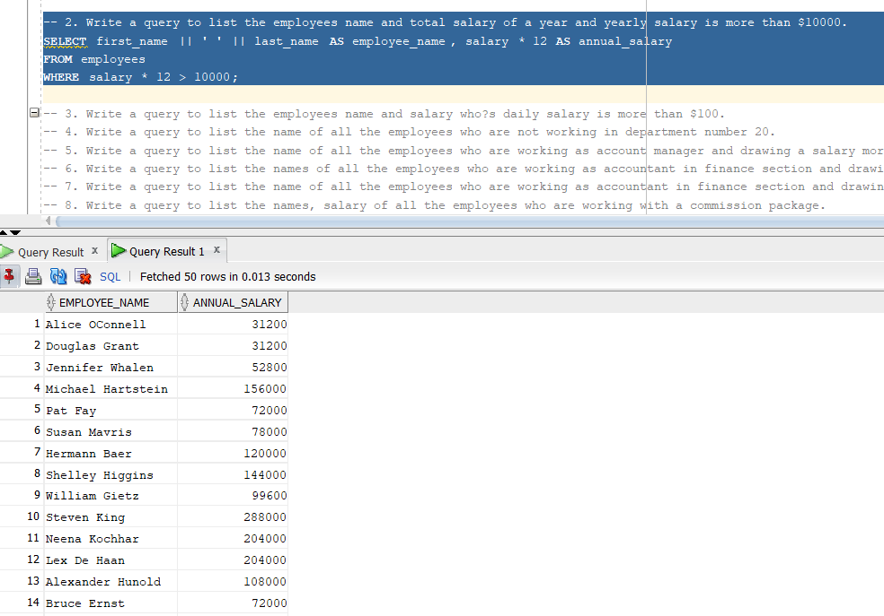

3. Write a query to list the employees name and salary who?s daily salary is more than $100. 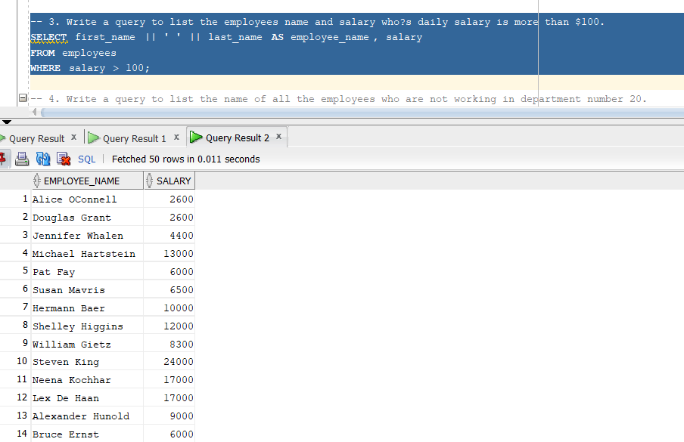

4. Write a query to list the name of all the employees who are not working in department number 20. 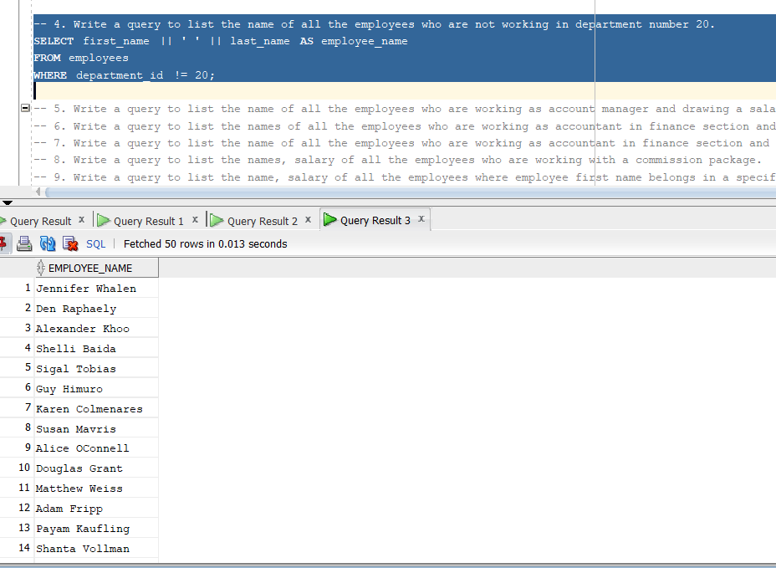

5. Write a query to list the name of all the employees who are working as account manager and drawing a salary more than $5000. 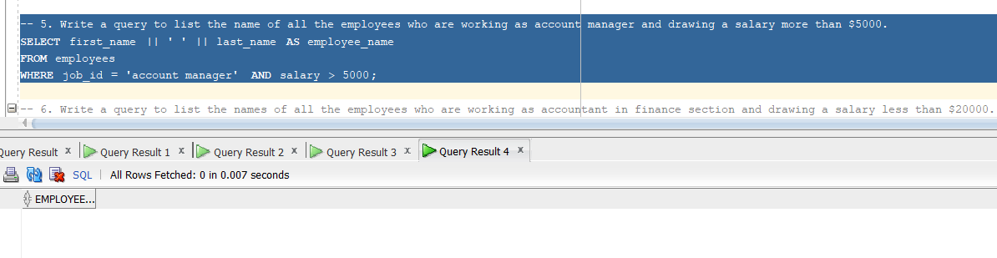

6. Write a query to list the names of all the employees who are working as accountant in finance section and drawing a salary less than $20000. 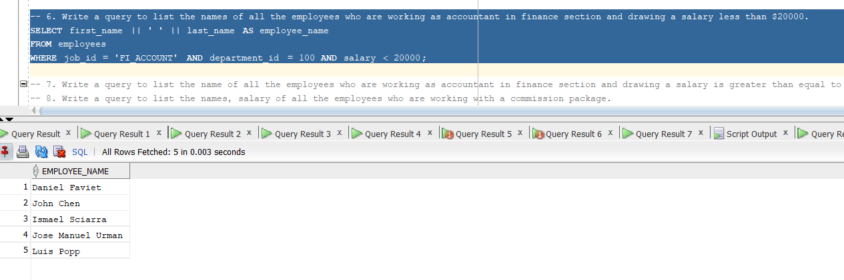

7. Write a query to list the name of all the employees who are working as accountant in finance section and drawing a salary is greater than equal to $5000 and less than equal to $20000. 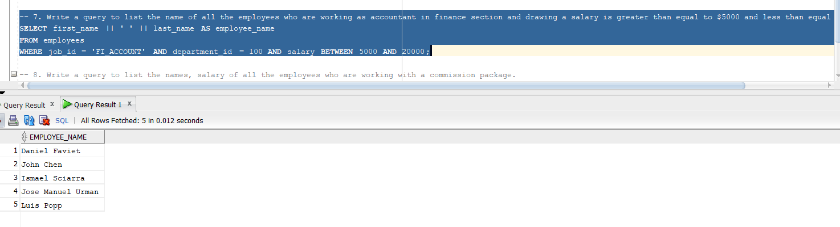

8. Write a query to list the names, salary of all the employees who are working with a commission package. 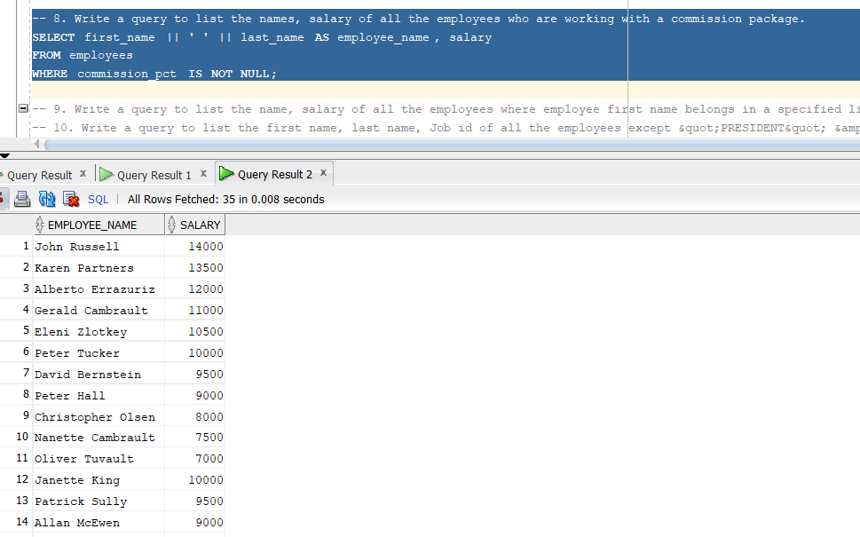

9. Write a query to list the name, salary of all the employees where employee first name belongs in a specified list. 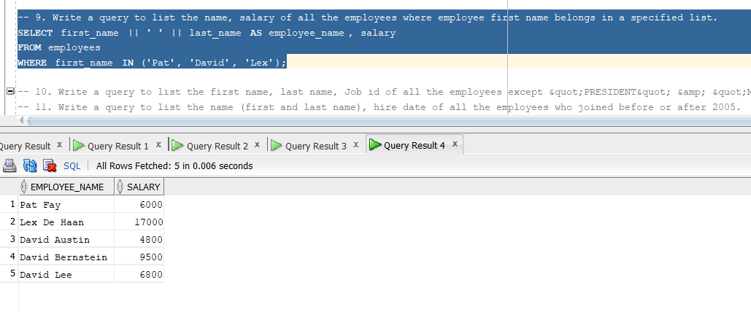

10. Write a query to list the first name, last name, Job id of all the employees except

&quot;PRESIDENT&quot; &amp; &quot;MGR&quot; in asc order of Salaries. 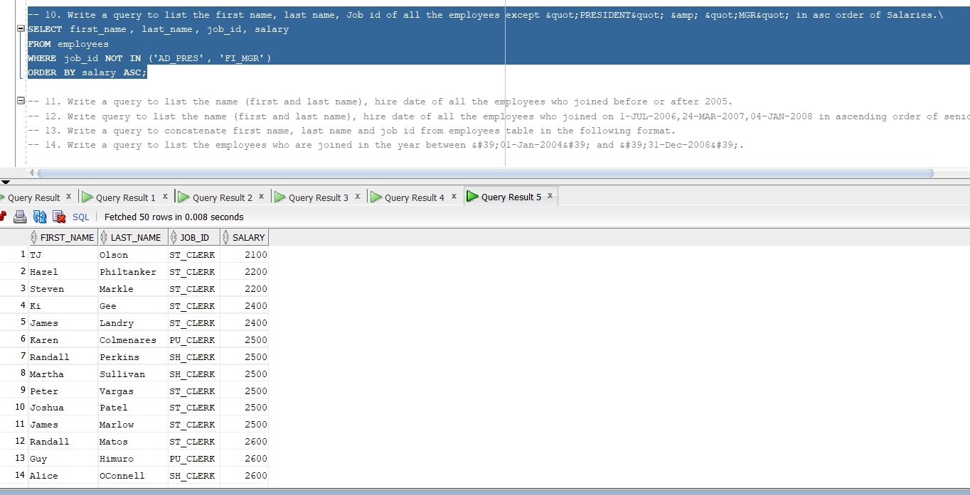

11. Write a query to list the name (first and last name), hire date of all the employees who joined before or after 2005. 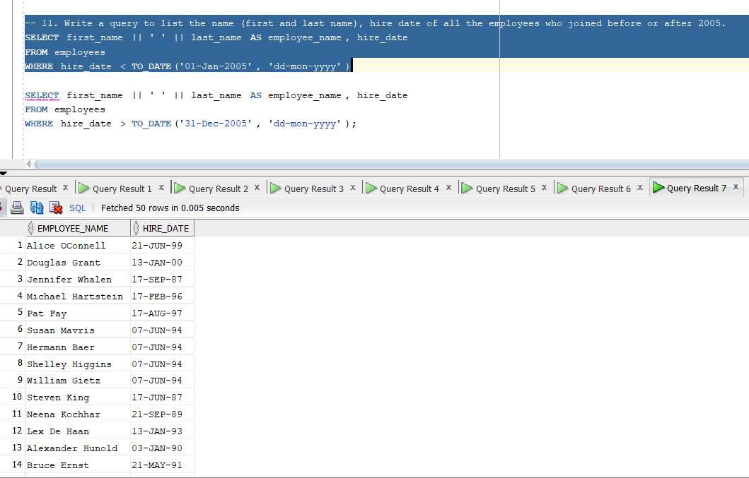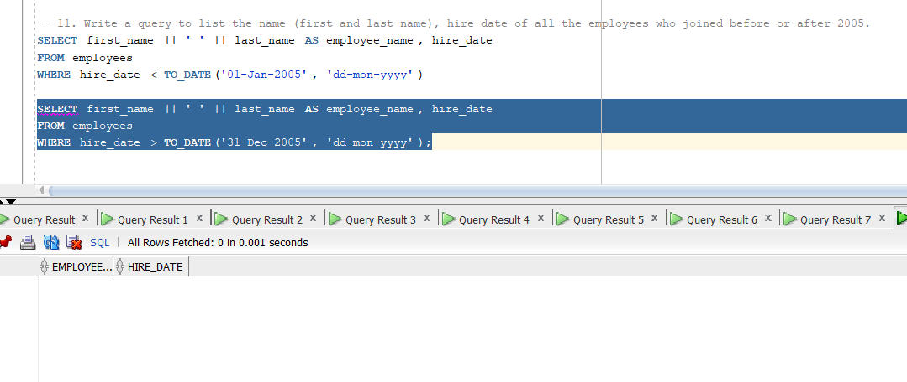

12. Write query to list the name (first and last name), hire date of all the employees who joined on 1-JUL-2006,24-MAR-2007,04-JAN-2008 in ascending order of seniority.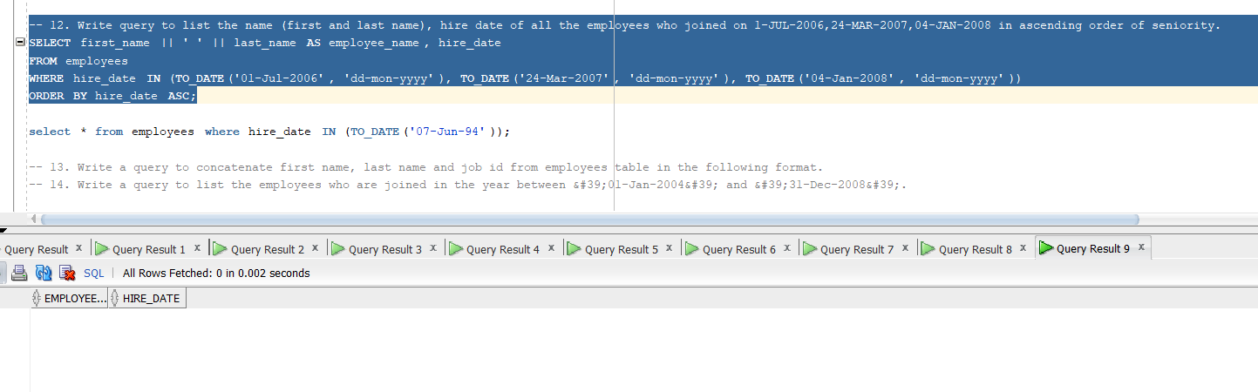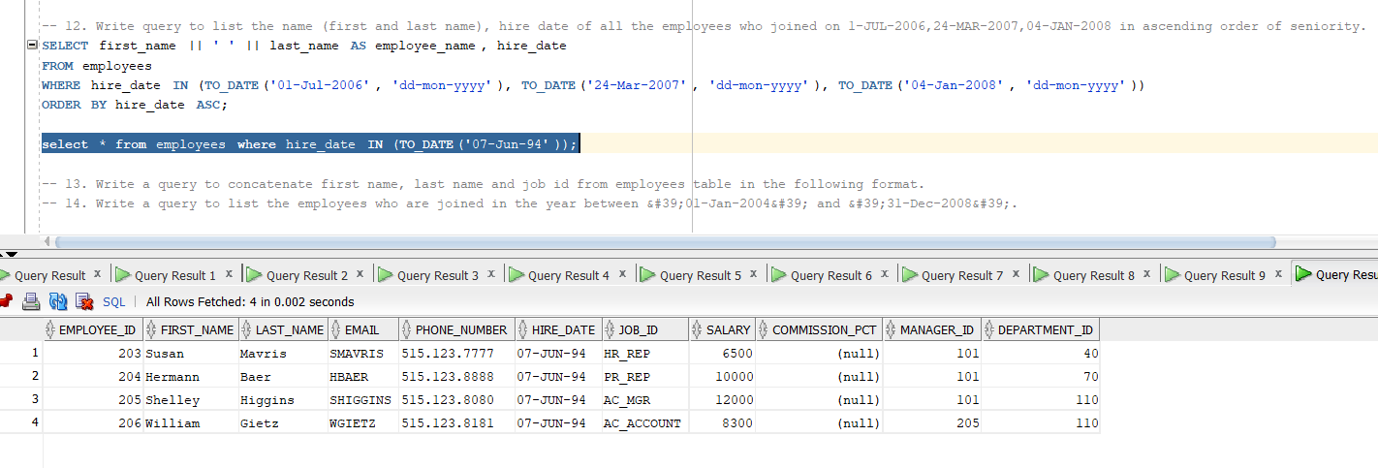

13. Write a query to concatenate first name, last name and job id from employees table in the following format. 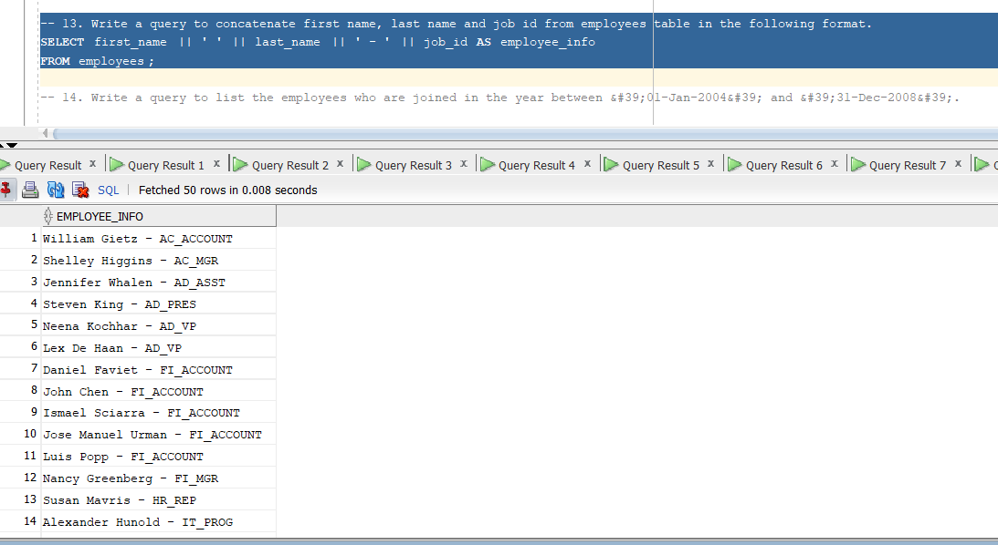

14. Write a query to list the employees who are joined in the year between &#39;01-Jan-2004&#39; and &#39;31-Dec-2008&#39;. 